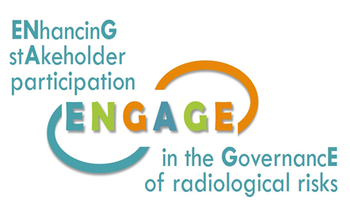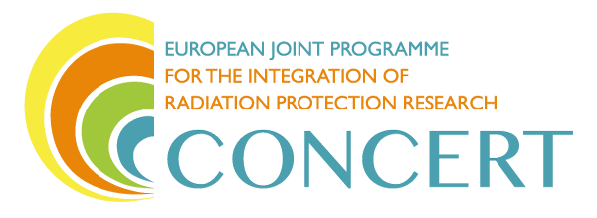

This project has received funding from the European Union’s Horizon 2020 research and innovation programme under grant agreement No 662287.

**EJP-CONCERT**

**European Joint Programme for the Integration of Radiation Protection Research**

**H2020 – 662287**

|  |
| --- |
| **Protocol for the analysis in tasks 1.1, 1.2, 1.3 of WP 1** |

**Lead Authors:** Michiel Van Oudheusden (SCK•CEN), Nadja Zeleznik (EIMV), Catrinel Turcanu, Bieke Abelshausen (SCK•CEN), Christiane Pölzl-Viol (BfS), Marie-Claire Cantone (UMIL)

**Reviewer(s):** ENGAGE partners - internal review

|  |  |  |
| --- | --- | --- |
| Work package / Task | **WP 9** | **T 9.4** |
| Deliverable nature: | **Milestone 1.1** | |
| Dissemination level: (Confidentiality) | **Public** | |
| Contractual delivery date: | **Month 34 (ENGAGE M4)** | |
| Actual delivery date: | **Month 34 (ENGAGE M4)** | |
| Version: | **0** | |
| Total number of pages: | **12** | |
| Keywords: | **Methodology, document analysis** | |
| Approved by the coordinator: | **Month 34 (ENGAGE M4)** | |
| Submitted to EC by the coordinator: | **N/A** | |

Document ID: ENGAGE (WP1)-(2018)-4

Disclaimer:

The information and views set out in this report are those of the author(s). The European Commission may not be held responsible for the use that may be made of the information contained therein.

|  |
| --- |
| **Abstract**  This document describes the protocol for the analysis of documents collected for the purpose of the WP 1 “Rationales and frameworks for stakeholder engagement in radiation protection”. It summarises the activities within WP 1 as agreed in the ENGAGE Kick-off meeting and as specified in more detail in subsequent discussions with project partners. It describes the methodological approach developed for the purpose of investigation and clarifies the division between WP 1 and WP 2 “Stakeholder engagement in practice”.  This milestone is the first report related to the contextual work in WP 1 and provides information for all the partners involved, in order to harmonize the analysis in terms of extent and content. It also addresses the relation to the complementary work package WP 2 in order to avoid overlaps or gaps in the analyses performed. |

**CONTENT**

1. Introduction and WP1 overview 5

2. Links between ENGAGE WP 1 and WP 2 7

3. ENGAGE methodology for WP 1 8

4. Organisation of work 11

5. References 13

# Introduction and WP1 overview

The ENGAGE project, funded under the H2020 CONCERT, aims at *ENhancinG stAkeholder participation in the GovernancE of radiological risks.* It is a two-year project that started on November 20th, 2017, and which seeks to identify and address key challenges and opportunities for stakeholder engagement in relation to medical use of ionising radiation; post-accident exposures; and exposure to indoor radon. In all these situations, stakeholder engagement is a key issue for improving the governance of radiological risks and the radiation protection of the exposed individuals.

The project aims are:

1. to assess why, when and how stakeholders engage in radiation protection;
2. to develop novel approaches to analysing stakeholder interaction and engagement, and provide guidance to meet the challenges and opportunities identified in response to (a);
3. to investigate the processes for enhancing radiation protection culture and their role in facilitating stakeholder engagement, and develop guidelines for building radiation protection culture; and
4. to build a joint knowledge base for stakeholder engagement in radiation protection.

The ENGAGE project is organized in four main work packages (WP) coordinated by the management WP, which interact to achieve the objectives as presented on the Figure 1.

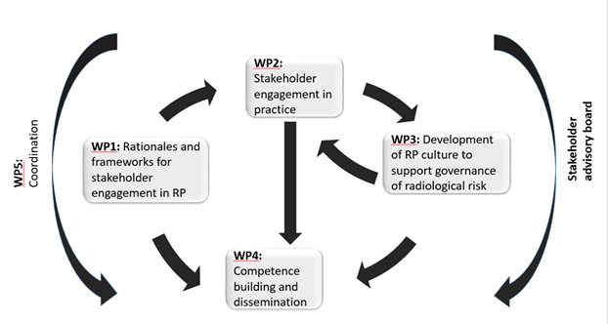

Fig. 1 Interaction between ENGAGE work packages

ENGAGE WP 1 on *Rationales and frameworks for stakeholder engagement in radiation protection* will clarify the rationales for stakeholder engagement in radiation protection and the related legal or contextual drivers (why does stakeholder engagement occur, who is involved and for what purpose). WP1 will examine institutional and non-institutional stakeholders (e.g. EU bodies, national governments, responsible decision makers, nuclear lobby, civil society organisations), what their attitudes and involvement are in relation to public participation into radiation protection issues, and finally if and how these positions can be aligned with the demands of Aarhus and other conventions, EU directives, international and national guidelines, bottom-up guidelines (e.g. from Citizen Science organisations), and general demands for public participation.

WP 1 aims to investigate the rationales for stakeholder engagement in three different field of radiation protection as:

* 1. formulated in EU policy discourse (e.g. Responsible Research and Innovation, past and on-going research),
  2. formulated in legal requirements and international guidelines related to radiation protection or related to environmental matters (EURATOM BSS and other directives), conventions (Aarhus, ESPOO, …) and guidelines from ICRP, IAEA, OECD,
  3. mobilised by different actors at national and international level in the radiation protection field (examples: organised regulatory authorities as in ENSREG and HERCA, NTW, technical RP platforms and other).

The investigation will be focused on the participation analyses at macro-level and will look at the European and international discourse for stakeholder engagement, what is prescribed and required, how these prescriptions are transposed at national level in participating countries and what is the extent and justification for stakeholder engagement. Based on the obtained information and analyses within the WP1, the conceptualization of the frameworks in which stakeholders are engaged in radiation protection will be developed.

WP1 is divided in 4 tasks, where three tasks (1.1, 1.2 and 1.3) correspond to three radiation protection contexts as for the whole ENGAGE, and the fourth one (1.4) is the methodological and also comparative task. The research methods to be used are document analysis of all publicly available material related to legal requirements and recommendations for stakeholder engagement in three fields of radiation protection, and interviews with relevant actors in the participating countries and at the international level (EU level and international organisations such as NEA and IAEA). Task 1.4 will draw on results from other three tasks to assess differences and commonalities between stakeholder engagement in different exposure contexts. In addition, it will analyse transversal European discourse promoting inclusiveness and stakeholder engagement in science policy.

Task 1.1 relates to stakeholder engagement in the medical field and is led by UMIL with participation of BFS, JSI (EIMV) and ISGlobal. The basic information will be collected from documents of European and international institutions and health care organisations (EC, ICRP, WHO, IAEA, HERCA). Also, consultations with different stakeholder groups will be performed with due attention for justification and optimisation in the framework of the informed consent processes. Stakeholders include patient representative organisations, medical doctors, medical physicists, radiographers, other medical staff, health authorities, scientific and professional bodies, manufacturers and suppliers. Contacts will be established with representatives of EURAMED, MELODI, EURADOS and WONCA.

Task 1.2 deals with stakeholder engagement in relation to emergency and recovery preparedness and response and is led by JSI (EIMV) with participation of SCK•CEN, ISGlobal and UMIL. Within this task an analysis of documents will be performed, such as BSS directive, OECD-NEA guidelines, ICRP publications, and other. In addition, lessons identified in the post-Fukushima context will be investigated along with requirements from Civil Society Organisations, NGO’s. Different groups of stakeholders will be consulted like authorities (nuclear, civil protection, local authorities), other involved services (rescuers, fire protections organisations, health professionals), the nuclear industry, TSOs, local population, CSOs &NGOs, citizens initiatives, NERIS and EURADOS platforms.

Task 1.3 investigates stakeholder engagement in relation to indoor radon exposures and is led by BfS with participation of SCK•CEN and JSI (EIMV). The basic document which will be analysed include EU BSS directive, recommendations and guidelines from IAEA, HERCA and ICRP, publicly available material related to legal requirements and international recommendations for stakeholder engagement in relation to indoor radon exposure, recent policy documents that are now calling for Member States to make arrangements for public involvement in relation to radon exposures. The obtained results will be supported by interviews with relevant actors.

Task 1.4 on transversal issues and specifics of different exposure situation will first develop a protocol for the analysis to be carried out in Tasks 1.1, 1.2 and 1.3. and then use the investigation and analysis of rationales and frameworks for the three exposure situations to analyse the transversal issues in terms of stakeholder engagement which could be synthesized as a general framework and the specifics of different exposure situations. Within the WP 1 two deliverables will be produced: report on rationales and frameworks for stakeholder engagement in radiation protection in the medical field, nuclear emergency and recovery preparedness and response and indoor radon exposure and report on stakeholder engagement in radiation protection: transversal issues and specifics of different exposure situations.

# Links between ENGAGE WP 1 and WP 2

ENGAGE WP2 on *Stakeholder engagement in practice* will complement the analysis of WP1 with a study of how stakeholder engagement in radiation protection issues is enacted in practice and what its impact is on radiation protection decision-making. This will include highlighting participation models and tools used; factors that can promote or obstruct stakeholder engagement (legal, political, economic, cultural, social, ethical); institutional and non-institutional forms of participation; challenges to, and limits of, participation. The outcomes, related to three exposure situations (tasks 2.2, 2.3, 2.4), will evaluate the impact of past or on-going participatory activities in radiation protection decision-making processes (or of their absence), assess if stakeholder engagements in the different fields of radiation protection are comparable and look at which broader lessons can be learned, what is specific to each field and why.

As a division between WP 1 and WP 2 the following guiding questions will be used:

* WP 1: What are radiation protection (RP) communities[1] being asked/expected to do? That is, what “external” pressures, mandates, demands, and/or expectations have emerged in public venues commending the engagement of stakeholders (including wider publics) in RP?
* WP 2: What are RP communities doing? That is, how are RP communities responding to these pressures, mandates, demands, or expectations and how does this show in practice (e.g. specific cases)? Which (other) real or potential forms of stakeholder engagement can be observed in RP practice, showing no reference to existing requirements?

The relations between WP1 and WP2 are illustrated in Figure 2. The analysis in WP 1 is the macro level, the object of analysis being discourses that justify and/or prescribe stakeholder participation related to radiation protection. This will be done based on document analysis and semi-structured interviews with key actors per field (e.g. policy makers). WP2 will look instead at how these prescriptions and expectations are enacted in practice and inform (or not) national and EU level policy. The object of analysis for WP 2 are practical examples and cases, where the methods of investigation may include interviews, observations, website analyses, group discussions, surveys.

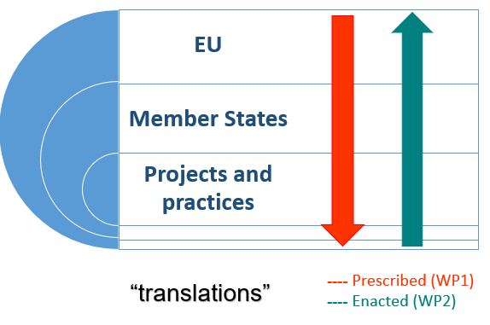

Figure 2: Levels of analyses for WP 1 and WP 2

# ENGAGE methodology for WP 1

**Project entry points**:

ENGAGE defines stakeholders as: actors (individuals or groups, institutional and non-institutional) with a tangible or intangible (yet to be shaped or discerned) interest in the radiation exposure situation and the related radiation protection issues, directly affecting decisions, or affected by the formulation and resolution of a problem or challenge. In this perspective, stakeholders are “constructed” in interaction with actors and issues. In other words, the notion of stakeholder is not fixed, but changes over time. Public(s) are also (potential) stakeholders.

Stakeholder engagement and informed decision-making are nowadays recognized as essential factors for an effective governance of radiological risk. However, the practical implementation of policy and legal requirements for stakeholder engagement is confronted with multiple challenges.

We must therefore better understand *why, when* and *how* stakeholders are engaged in radiation protection. This understanding is necessary to facilitate the development of guidelines and a knowledge base for a more robust stakeholder engagement in radiation protection (among others; see project description).

**Object of analysis:** Macro-level discourses that justify and/or prescribe stakeholder participation in RP

**Methods:** Document analysis and semi-structured interviews with key actors per field (e.g. policy makers, stakeholder group representatives). For instance in emergency preparedness and response, key actors could be civil protection, nuclear or radiation protection regulators, local municipalities, operators (NPPs or other), local population, NGOs, other. One or two interviews with each of these key actors would suffice.

**Data:** Public documents and interview transcripts

**Data sources[2]**:

* EU policy legislation, policy briefs, presentations, also research calls
* Related EC directives and other EU level adopted conventions (Aarhus, ESPOO,…)
* Reports and guidelines from international organisations (e.g. IAEA, OECD-NEA, HERCA, ICRP, ENSREG,…)
* Regulatory and legal documents (national level)
* Statements or documents from RP communities (e.g. research platforms)
* Civil Society statements, press releases, reports

**Operationalization for WP 1:**

The following questions and terms can be used as *sensitizing concepts;* that is, as constructs that sensitize us to possible lines of inquiry, and which can be adapted to the case at hand and the developments that ensue during fieldwork (van den Hoonard, 1997).

1. What local, regional, national or international sources justify or prescribe stakeholder engagement and public participation in RP? In addition to formal policies and actors, consider other formal and/or informal sources.
2. Which actors (and which networks) are being summoned/expected to engage or participate in RP, by whom, when, why and how? Are there differences between the three exposure contexts investigated and if so, what is the underlying justification of such differences?
3. How do the actors mentioned above (policy-makers, regulators, CSO’s (civil society organisations), international organisations, etc) define “stakeholder” and how do they understand stakeholder engagement? What are their expectations from such processes?
4. Can you identify aspirations for or trends (over time) towards more or less stakeholder involvement (e.g. engagement of particular social groups)? Can you identify any tensions, ambiguities, contradictions, or divergences present in or indicated by these prescriptions?
5. What potential implications do these conceptions entail for RP institutes, communities, platforms, and researchers? For scientific practice, conduct, or education? For your specific case? For others who participate in (nuclear) research and development related to ionizing radiation?
6. What else have you found, or should we be asking?

To answer these questions, it can be helpful to highlight:

* **motivations for participation:** *instrumental* (it is applied to secure an end point)*, normative* (e.g. “it is the right thing to do”, it responds to a certain principle)*,* and *substantive* (it is applied to achieve better decisions)[3];
* **level of participation**: considering e.g. the influence on decisions, the purpose of participation, the interactions between stakeholders (see an example as in Figure 3);
* **frames** used to define / recommend engagement: assess how prescriptions explicitly or implicitly convey a *problem definition, moral evaluation,* and *treatment recommendation* (Entman, 1993).

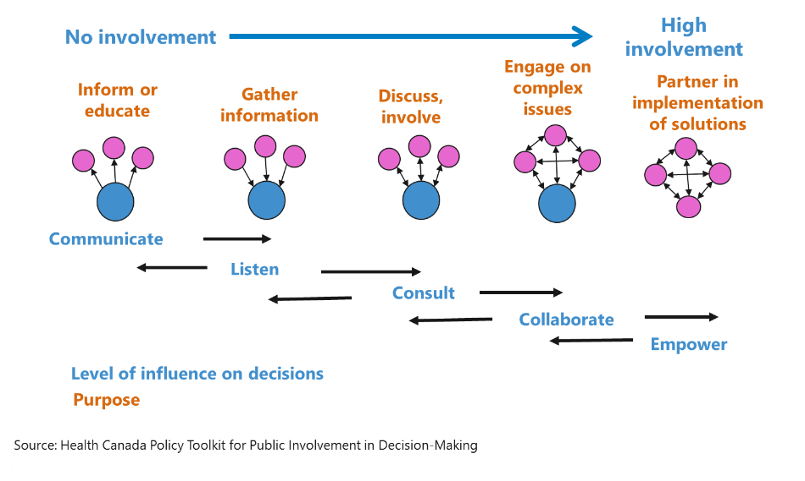

Figure 3: Possible interaction with stakeholders and levels of influence

In order to facilitate analysis, whenever appropriate (e.g. large documents), the parts to be analysed in detail will be identified using the following keywords and extracted for further reference:

* stakeholder(s);
* actor(s);
* participant(s);
* engagement;
* participation;
* involvement;
* interested party/parties;
* public.

**Example of operationalization for WP 1:**

**Analysing EU science policy paradigm / macro discourse of Responsible Research and Innovation (RRI)**

**Extracts from documents:**

*[1] “Building on the success of Science in Society projects in engaging the general public and civil society in debates around science, RRI aims to go one step further and engage all societal actors – from researchers through policy makers, to citizens, businesses, etc. – to work together throughout the research and innovation process in order to ensure that the results meet the needs of the world we live in.”* (European Foundation Centre, 2012)

*[2] “RRI refers to the comprehensive approach of proceeding in research and innovation in ways that allow all stakeholders that are involved in the processes of research and innovation at an early stage (A) to obtain relevant knowledge on the consequences of the outcomes of their actions and on the range of options open to them and (B) to effectively evaluate both outcomes and options in terms of societal needs and moral values and (C) to use these considerations (under A and B) as functional requirements for design and development of new research, products and services. The RRI approach has to be a key part of the research and innovation process and should be established as a collective, inclusive and system-wide approach.”* (EU’s Directorate General for Research and Innovation, 2013)

**Analysis:**

**What local, regional, national or international sources justify or prescribe stakeholder engagement?** EU, EFC

**Stakeholder:** all societal actors – from researchers through policy makers, to citizens, businesses, etc.

**When to engage:** *at an early stage; work together throughout the research and innovation process*

**Frame and framing components**

* **Problem definition:** The introduction of science and technology into society fails when this process and the values it stands for conflict with societal values.
* **Moral evaluation:** Societal needs and values need/deserve to be heard and aligned with scientific research and innovation agendas.
* **Treatment recommendation:** The scientific, policy, and industry communities must solicit society’s views by listening to what society has to say about science and technology innovations.

**Rationales: why engage?**

* ***Substantive****:* to improve decisions, policies, and assessments by including as many viewpoints as possible in research and innovation
* ***Instrumental****:* to support preconceived, often short-term policy commitments (e.g. educating citizens about science)
* ***Normative/democratic****:* because it’s the morally right thing to do.

**What are the venues for engagement: local, regional, etc?**

Level of Member States:

* RRI prominent in NL, DK, UK, GER, to a lesser extent in Fl
  + e.g. NL: “maatschappelijk verantwoord innoveren”: “Responsible Innovation programme” (NWO-MVI)
  + Typically countries and regions:
    - with a strong STI knowledge base (that heavily invest in new and emerging technologies and innovation)
    - and with established traditions of science-society mediation (e.g. technology assessment).

EC’s “RRI tools” contains many case examples: <https://www.rri-tools.eu/>

**Link with RP and ENGAGE**

RRI is distinct policy, not found in EURATOM. However, RP actors (technical researchers, science policy makers, oversight bodies) stress the importance of stakeholder involvement and ongoing dialogue between scientific experts, civil society organizations, and publics in the face of nuclear risk governance challenges (e.g. EURATOM directives)

In addition, RP actors increasingly summon SSH researchers to help them identify and manage “the needs in radiation protection for the public” (e.g. “European radiation protection research: Outcome of Euratom integration policy and future perspectives,” May 2017)

# Organisation of work

For the purpose of implementation of the WP 1 activities a plan was developed for the year 1 as following:

* Collection of documents – each task leader (per field: medical, EP&R and radon) and all participants in WP 1 – until 25/1/2018
* First analysis of collected documents –according to distribution –all – 28/2/2018
* Identification of related stakeholders (per field) - task leaders and participants – 15/3/2018
* Protocol for analysis for W1 tasks 1-3 – WP 1 leader(s) and task leaders – 30/3/2018
* Analysis of documents – all participants of WP1 – 15/5/2018
* Legal provisions identified and provided as input to WP2 – WP leader - 30/5/2018
* Interviews with key actors – all participants of WP1- 30/6/2018
* Transcription of the interviews – all participants of WP1 -30/7/2018
* First draft of results – input for D1.1 – tasks leaders - 30/7/2018
* Collection of findings from the draft report – tasks leaders- 30/8/2018
* Analyses of first results and consultations – identification of missing points – all participants - 30/8/2018
* Development of draft D1.1 – tasks leaders- 20/11/2018

Based on collected documents it is proposed to distribute the work on analysis of documents as presented in the table 1 bellow:

|  |  |  |  |  |
| --- | --- | --- | --- | --- |
| **Document area** | **General (lead Bieke, Nadja)** | **Medical (Marie-Claire)** | **EP&R (Nadja)** | **Radon (Christiane)** |
| EU policy legislation, policy briefs, presentations, also research calls | RRI example included in methodology document | Marie-Claire | Nadja | Christiane |
| Related EC directives and other EU level adopted conventions (Aarhus, ESPOO,…) | Nadja, Bieke | Marie-Claire | Nadja | Christiane |
| Reports and guidelines from international organisations (e.g. IAEA, OECD-NEA, HERCA, ICRP, ENSREG,…) | Bieke | Marie-Claire | Nadja | Christiane |
| Regulatory and legal documents (national level) |  | Marie-Claire (I), Nadja (Si), Liudmila (S), Christiane (D) | Nadja (Si), Catrinel (B),  Marie-Claire (I), Liudmila (S),  Tanja-Catrinel (survey data with 25 EU MS) | Christiane (D), Tanja (B), Nadja (Si), |
| Statements or documents from RP communities (e.g. research platforms) | All | Marie-Claire | Nadja | Christiane |
| Civil Society statements, press releases, reports | All | Marie-Claire | Nadja | Christiane |

Based on the results from analysis of documents the key stakeholders for further interviews will be defined. It is expected to develop a new revision of this milestone to propose a common approach and guiding questions for open interviews.

# References

Entman, R. M. 1993. “Framing: Toward Clarification of a Fractured Paradigm.” Journal of Communication 43 (3): 51-58.

Haas, P. M. (1992). Introduction: epistemic communities and international policy coordination. *International organization*, *46*(1), 1-35.

van den Hoonard, W. (1997). Working with sensitizing concepts. Analytical field research. London: Sage.

1. RP community understood as an epistemic community (Haas 1992): “...a network of professionals with recognised expertise and competence in a particular domain and an authoritative claim to policy relevant knowledge within that domain or issue-area.”
2. Available on the ENGAGE SharePoint: <https://extranet.sckcen.be/sites/engage/_layouts/15/start.aspx#/SitePages/Home.aspx?RootFolder=%2Fsites%2Fengage%2FShared%20Documents%2FREFERENCES&FolderCTID=0x012000938363D12D14F74FB00E25B83BEEA780&View=%7BADFC742E%2D13A8%2D449D%2DA78A%2D794BD66B7A22%7D>
3. (see e.g.: <https://assets.publishing.service.gov.uk/media/57a08c6ce5274a31e00011ee/1052734439-stirling.2005-opening.pdf>)