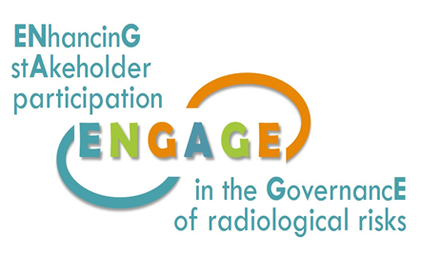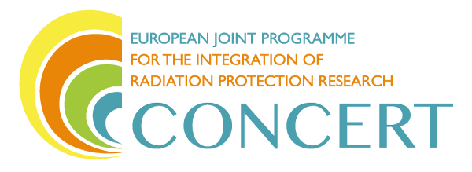

This project has received funding from the European Union’s Horizon 2020 research and innovation programme under grant agreement No 662287.

**EJP-CONCERT**

**European Joint Programme for the Integration of Radiation Protection Research**

**H2020 – 662287**

|  |
| --- |
| **Round table discussions on stakeholder engagement in practice**  ***held jointly with the******NERIS Working Group 4 ‘Information, Participation and Communication’***  at the  **4th NERIS Workshop on April 25, 2018, in Dublin** |

**Catrinel Turcanu, Bieke Abelshausen, Tanja Perko, Michiel Van Oudheusden (SCK•CEN), Tatiana Duranova (VUJE), Nadja Zeleznik (EIMV), Eduardo Gallego (UPM)**

Document ID: ENGAGE (WP1)-(2018)-8

Disclaimer:

The information and views set out in this report are those of the author(s). The European Commission may not be held responsible for the use that may be made of the information contained therein.

|  |
| --- |
| **Summary**  Round tables were conducted to discuss different questions relevant for the ENGAGE project with representatives of authorities, technical specialists and researchers at the annual 2018 NERIS workshop in Dublin. The round tables were organised jointly with the NERIS Working Group on Information, Participation and Communication. In parallel, the implementation of requirements for public information and transparency in the revised Basic Safety Standards and Nuclear Safety Directive was discussed in the framework of the European project tasked with this study.  The topics of discussion were:   * Frameworks and rationales for stakeholder engagement, * A knowledge base for stakeholder engagement practices, * Public information and transparency.   For each of these topics several questions were discussed with participants of the NERIS workshop. With regards to frameworks and rationales for stakeholder engagement there is, in general, an agreement that stakeholders can be understood very broadly, including for instance any person or group who is or can be affected by a radiation protection decision or action, either actively engaged or not; or has an interest or a stake in the decision, whether this interest is discerned or not; or can influence the decision. Sometimes diverging opinions were stated in relation to identifying stakeholders. A challenge is to ensure a good representation, accounting also for those stakeholders who cannot participate (for example, future generations).  The participants expressed diverse opinions on why to involve stakeholders: e.g. there is no other choice, they are there, or to improve the response in case of an accident. In some countries there exist legal provisions for stakeholder engagement, while in others it is merely recommended. It is fairly agreed upon that stakeholders should be involved in the preparedness phase, as they will better understand and manage the accident. Participants considered important the distinction between decision-makers and stakeholders, and made a point that the responsibility for the accident lies with the nuclear emergency and safety managers, and not with the other stakeholders.  With regards to the ENGAGE knowledge base for recording stakeholder engagement experiences, it was emphasised this should have easily searchable electronic form, providing comprehensive information on objectives, organiser, stakeholder involved, challenges of the process, power asymmetries, use of mediator, sustainability of the process, participatory method, among others. The stakeholder panels in the TERRITORIES and CONFIDENCE projects could be used as input for a pilot database, taking stock also of the previous NERIS-TP work on a stakeholder engagement database for emergency management.  The requirements on public information and transparency in emergency situation from the BSS Nuclear safety directives are interpreted and implemented differently in EU Members States: some did not change the current approach and others used the revision of these documents as an opportunity for improvement of their current provisions. Good practices were highlighted e.g. permanent call centres independent from authorities, involvement of local communities in emergency exercises, facilitating and supporting individual radioactivity monitoring. Aside of the revision of EU prescriptions, main triggers for changes in approaches to public information and stakeholder engagement were the accident in Fukushima, the role of social media and the involvement of NGO’s. The discussion also revealed that in general the participants support wider participation of stakeholders and see the new directives as an opportunity for implementation. |

CONTENTS

1 ENGAGE project overview 5

2 NERIS “Working Group on Information, Participation and Communication” 5

3 Round table discussions on stakeholder engagement in practice 7

3.1 Frameworks and rationales for stakeholder engagement 7

3.2 Knowledge base for stakeholder engagement 8

3.3 Public information and participation in light of – but also beyond - the revised BSS and Nuclear Safety Directive 10

Annex 1 Invitation to the workshop 12

Annex 2 Agenda of the workshop 13

# ENGAGE project overview

The ENGAGE project, funded under the H2020 CONCERT, aims at *ENhancinG stAkeholder participation in the GovernancE of radiological risks.*

ENGAGE is a two-year project started on November 20th, 2017 that seeks to identify and address key challenges and opportunities for stakeholder engagement in relation to medical use of ionising radiation; post-accident exposures; and exposure to indoor radon. In all these situations, stakeholder engagement is a key issue for improving the governance of radiological risks and the radiation protection of the exposed individuals.

The project aims are:

1. to assess why, when and how stakeholders engage in radiation protection;
2. to develop novel approaches to analysing stakeholder interaction and engagement, and provide guidance to meet the challenges and opportunities identified in response to (a);
3. to investigate the processes for enhancing radiation protection culture and their role in facilitating stakeholder engagement, and develop guidelines for building radiation protection culture; and
4. to build a joint knowledge base for stakeholder engagement in radiation protection.

Through its research and innovation activities, ENGAGE will inform stakeholder engagement approaches to radiation protection in ways that all relevant stakeholders find meaningful and legitimate. It will contribute to improving radiological risk governance and radiation protection itself. Its beneficiaries are radiation protection researchers, policy makers, civil society stakeholders and wider publics.

ENGAGE is part of CONCERT. This project has received funding from the Euratom research and training programme 2014-2018 under grant agreement No 662287.

# NERIS “Working Group on Information, Participation and Communication”

NERIS Working Group on Information, Participation and Communication (WG IPC) has been created in January 2016 in Bratislava, Slovak Republic at the final Workshop of PREPARE project with focus on the information, participation and communication of the public in post-accidental situation.

The objectives of NERIS WG IPC stated in 2016 were following:

* To elaborate on the conclusions and recommendations of PREPARE WP6 & WP3, with regard to
  + information to the public,
  + communication among experts and stakeholders, and
  + the participation of the relevant stakeholder in the Emergency Preparedness and Response (EPR) processes,
* To create a group of users of the “Analytical Platform” developed in PREPARE,
* To have a forum of exchange of ideas and experiences within NERIS and with international organisations or groups interested in the WG topics.

Second meeting of the WG IPV took place at the CONCERT RPW, September 2016 in Oxford, United Kingdom. Following that activities and discussions a dedicated WG IPC section on the NERIS website has been created in 2017.

Wide range of activities has been proposed based on discussion of WG IPC members. Due to lack of projects behind, and lack of time to participate, the activities proposed have not been done.

After CONCERT EJP initiation, new perspectives with projects like CONFIDENCE, TERRITORIES, SHAMISEN-SINGS and ENGAGE has occurred. Therefore, it was proposed to link the activities of the WG to these new projects. During the NERIS Platform workshop meeting of WG IPC took place on April 25, 2018 in Dublin, Ireland.

The objectives have been redefined as follows:

* To elaborate on the conclusions and recommendations of PREPARE, CONFIDENCE, TERRITORIES, SHAMISEN-SINGS and ENGAGE, with regard to
  + information to the public,
  + communication among experts and stakeholders, and
  + the participation of the relevant stakeholder in the EPR processes,
* To have a forum of exchange of ideas and experiences within NERIS and with international organisations or groups interested in the WG topics; this could be created in the Analytical Platform (AP).

Based on previous experience the topics have been updated to following:

1. Information and participation of the public.
   1. Communication among experts and stakeholders
   2. To support the local participation and gathering of information
   3. Interaction with traditional media and journalists
   4. Role of social media
2. Interaction and exchange of experience between experts
   1. Networking experts
   2. Feedback from the ICRP Dialogues in Fukushima (<http://www.icrp.org/page.asp?id=189>)
   3. To create a forum for the WG (using the AP or other platform)
   4. Interaction with the Eagle Platform (<http://eagle.sckcen.be/>)
3. Elements, tools or processes that can facilitate the EPR of local stakeholders
   1. Information of the public for preparedness
   2. Preparation, compilation, of easy-to-understand materials on scientific knowledge about radiation risk, nuclear accidents and radiological events
   3. Interaction with the stakeholders (bringing the experience from past and ongoing projects: NERIS-TP, PREPARE, CONFIDENCE, TERRITORIES, SHAMISEN-SINGS, ENGAGE).

A proposal of the particular activities is under discussion and responsible leaders and key contributors will be established at the end of this process.

Next NERIS WG IPC meeting is scheduled to take place during 5th NERIS Workshop in May 3/5, 2019 in Roskilde, Denmark.

# Round table discussions on stakeholder engagement in practice

Round tables were conducted to discuss different questions relevant for the ENGAGE project with representatives of authorities, technical specialists and researchers at the annual 2018 NERIS workshop in Dublin. The round tables were organised jointly with the NERIS Working Group on Information, Participation and Communication. In parallel, the implementation of requirements for public information and transparency in the revised Basic Safety Standards and Nuclear Safety Directive was discussed in the framework of the European project tasked with this study.

The topics of discussion were:

* Frameworks and rationales for stakeholder engagement,
* A knowledge base for stakeholder engagement practices,
* Public information and transparency.

A number of 44 participants attended the round tables. This included members of the NERIS Working Group on Information, Participation and Communication and other participants to the NERIS Workshop: nuclear safety authorities, radiation protection experts, members of international organisations. The invitation sent to all participants at the NERIS workshop is included in Annex.

## Frameworks and rationales for stakeholder engagement

Three questions were prepared for three round tables conducted during the NERIS workshop in Dublin on 25th of April 2018, however due to lack of time only the first two were addressed:

1. Who is (should be) a stakeholder in your experience?
2. Why should stakeholders be involved in emergency preparedness and response?
3. What are the strengths- weaknesses-opportunities and threats?

**Who is (should be) a stakeholder in your experience?**

When answering the question “who is (should be) a stakeholder in your experience”, it is noteworthy that participants to the round tables provide descriptive answers stating the underlying motivation for stakeholder engagement, rather than providing specific stakeholder groups. Stakeholders are described as people, persons, anybody who is affected by a decision or an action, who can affect a decision, who has a stake, who is engaged, who is involved, and even someone who is not involved.

Participants mentioned that stakeholders can be a person, an authority, a representative of a certain group, and that stakeholders do not necessarily have to be actively engaged, or even be directly involved or affected. A stakeholder can also be someone who *thinks* they will be affected by the decision, who has a good idea, or even the future generation.

The round table participants however also gave contradicting messages. For example, on the one hand a stakeholder is someone who is formally appointed or informally involved with the condition that they actively participate. However, stakeholder can also be the future generation, unable to actively participate, or children. The consensus here being that the representative of the inactive stakeholders, plays an active role. Finding these representatives or stakeholders groups is considered challenging.

The Aarhus convention was referenced stating the stakeholder is clearly defined as “the public concerned”; the public affected or likely to be affected by, or having an interest in, the environmental decision-making. This implies that NGO’s are also stakeholders with an interest and who can improve solutions, including anti-nuclear NGO’s. One participant indicated that these NGO’s should meet any requirements under national law.

Specific suggestions were made on how to define and limit the stakeholders involved. For example, a suggestion is made that at a local level those who are affected can be defined according to the distance from the incident or accident, those who were within the vicinity at the time, people who live in contaminated areas. Additionally, this includes people who visit the area on occasion, consumers of products from this area, taxpayers in general, etc. The determination of who stakeholders are, should however be targeted and dependent on the occasion and issue/topic of discussion.

An additional group of stakeholders that was suggested are students; those who are educated within the subject, try to transmit what is the problem, provide information on how to behave and address citizens vigilance. For example, in the case of radon, students should be informed and educated.

**Why should stakeholders be involved in emergency preparedness and response?**

When asking the question “why should stakeholders be involved in EP&R?” the answers are diverse. Initially it is stated that there is no other choice than to involve stakeholders. When dealing with an emergency, stakeholders are there; it is necessary to understand how they will react as great emergency plans are useless if they are not implemented.

The question is raised whether stakeholders should be involved in the emergency phase or rather in the preparedness. It is indicated that a shift has emerged towards the preparedness phase and the recovery phase. It is fairly agreed upon that stakeholders should be involved in the preparedness phase. The reasoning presented is that in case stakeholders are involved from the beginning, they will better understand and manage the accident as they are unwilling to just accept the situation (i.e. follow the recommendations). Stakeholders are considered as not the ones that should be responsible; indicating that they are willing to work together with nuclear emergency or safety managers, but it is their first duty to avoid the accident.

Additionally, it was noted that in some countries such as France it is legally obliged to involve stakeholders, in Ireland this is merely a suggestion. The reasons for being a stakeholder can also change; for example, if food is contaminated, consumers become stakeholders and even decision-makers. The participants suggest that it is however important to note that stakeholders and decision-makers are not considered the same.

## Knowledge base for stakeholder engagement

Three general questions were prepared for discussion related to the knowledge base for stakeholder engagement:

1. Which form of knowledge base for stakeholder engagement will make it meaningful for you?
2. Which information is most useful for you?
3. What is the best way of sharing the generated knowledge?

Because of the lack of time only two first questions were discussed within two groups.

As not all members of the working groups were familiar with previous development in that area under the NERIS activities and NERIS-TP research project, a short introduction and clarification of the status of the knowledge base development in the area of emergency preparedness and recovery was mentioned.

**Which form of knowledge base for stakeholder engagement will make it meaningful for you?**

The first suggestions related to the form of the knowledge base focused on following key aspects:

* Easily searchable, not a bunch of reports (e.g. post-accident info, list of stakeholders for issue, etc.)
* Electronic form
* Artificial Intelligence (Professor too expensive)
* Maintained repository of records (successful experiences, stakeholder panels, reports from organizations)
* Case studies (e.g. Fukushima and Chernobyl)
* Knowledge management techniques (compiled and analyzed reports, common repository, accessible to everyone)

For the form of knowledge base, it is important to have it searchable by keyword and with report capabilities, rather than compact documents.

Machine learning and AI offer search functionalities (see e.g. image search). However, context is also needed, e.g.: Who wrote the report? Why? When? How? What is the history of the document? Links to the authors are needed as well as links to related articles (e.g. in Research Gate).

An important question is how can transfer this knowledge to next generation? The question is who the target audience for the knowledge base. The target audience depends on the area of interest, on the stakeholders engaged. For instance, “decision-maker” could be a keyword, with the search results pointing to e.g. the goal of stakeholder engagement, the country, and the participants.

Within NERIS platform work led by Simon French developed a database structure that could be a good starting point for ENGAGE. This has been tested based on local forums (e.g. Norway, France, Slovak Republic). Stakeholders from different platforms and projects could be contacted, to ask about their interest in using the knowledge base.

Building the pilot for the ENGAGE knowledge base starting from CONFIDENCE activities could be good start.

**Which information collected in the knowledge base is most useful for you?**

The following information was suggested by participants as most useful:

* objectives,
* (types of) stakeholders,
* situation / topic / subject,
* methodology
  + type of material used,
  + participatory method, e.g. discussion, survey, scenarios.
* information from previous projects, previous experiences, synthesized such that it can be used in more efficient ways,
* which type of questions should be addressed to which type of stakeholder
* type of stakeholder to target in which situation.

It was suggested to add a set of basic concepts so that everyone is on the same page, everyone speaks the same language or at least understands each other. This could be ensured with links to existing documents where these concepts are used. The example of the previous work in NERIS-TP by Simon French and colleagues was given.

It was stressed by some participants that it is important to see that the process of engagement is not so simple and that it cannot deliver everything. It is important to be clear about the questions people are facing and have stakeholders’ views, provide examples drawing attention on real experience, highlighting things that (do not) work and what contributed to a good stakeholder process. The knowledge base should point out how were stakeholders engaged, how was the process kept alive or, opposite to this, why it didn’t work or failed.

The view was presented that discussions among stakeholders should allow everybody to “take off their hat”, facilitating open discussion where each stakeholder has the same right to talk, and there is power symmetry, with focus on ethics, and cooperation. It was agreed that it is important to have established rules of communication, not that someone tries to be above the rest. Among the stakeholders there can be controversial issues (e.g. disagreement on priorities). Not only vertical, also horizontal power asymmetries have to be followed during the discussions.

Connected to that, information on power asymmetries and the need for an independent mediator or facilitator in contact with stakeholders should be given in the knowledge base.

Two positive practices coming from Belgium were presented. Basic information on nuclear risk can be found at: [www.nucleairrisico.be/](http://www.nucleairrisico.be/) of the Crisis Centre. Anyone can access information, but the website includes also sections for specific target groups: pharmacists, healthcare professionals, first responders. The other example is the partnership approach for the low-level radioactive waste in Belgium, involving several local community stakeholders. The process proved to be successful, and at the same time long and challenging, and it allowed finding an agreement.

It was suggested to the group to start with documenting experiences from the CONFIDENCE and TERRITORIES projects. An important point is to emphasize that there is no one best approach and stakeholder engagement approaches have to be adapted to the situation.

## Public information and participation in light of – but also beyond - the revised BSS and Nuclear Safety Directive

One of the round table discussions was initiated by the European Commission project on the implementation of requirements for public information and transparency in emergency situations, laid out in the revised Basic Safety Standards and new Nuclear Safety Directive. The discussion focused on participation, information and transparency in practice, notably in light of – but also beyond - the new BSS and new Safety Directive.

The following questions were used as a starting point for the discussions:

1. How should Member States interpret the public information requirements from BSS and amended Nuclear Safety Directive?

2. Can you point out a specific good practice at the national level regarding information provision and transparency in case of an emergency?

The discussion points addressing issues of interest for ENGAGE are summarized in the following.

The discussants pointed out that it is not clear “*how a country should interpret the requirements”*. There are different approaches in Member Stats: some countries may just make a self-assessment that they fulfil these requirements already and nothing else is needed, while others can see in the revised BSS an opportunity for improvement. There is thus the question on whether the different countries enact the requirements minimally.

In Spain there are no new elements in the new decree concerning information to the public, social networks, citizen science, and communication is seen as mostly uni-directional. A distinction was pointed out between transposition and implementation of requirements. For instance in Spain there is no difference in transposition because arrangements are already in place; the main question is the implementation. “*What is important is what is meant in practice, how is it interpreted, what type of improvement could be advised*”. For instance, in France including ANCLI in emergency exercises is a way to test this aspect.

In Hungary, it is planned to include the communication plan as a part of the new emergency plan.

In Ireland, the BSS and Nuclear Safety directive are taken into the legislation, but in the plans of EPA they go beyond these requirements and engage with stakeholders. Plans are not in the legislation as such, but EPA has a decisive role in this respect. For instance, there are arrangements for stakeholder engagement in plans. The plan follows a multi-hazard approach and ensures that during an emergency the key stakeholder are involved (not members of the public). The stakeholder panel was created due to the European project PREPARE.

One participant voiced his opinion that the BSS requirement on the provision of information is meant as an obligation to provide information in a proactive way, but that it is difficult to regulate in advance stakeholder involvement and provision of information. CODIRPA doctrine in France includes however many aspects dealing with involvement of people.

In Switzerland permanent call centres in case of crisis are active in case of a crisis (all types of disaster), where people giving answers are medical staff. These are independent from the authorities (but still connected to it) and trusted by the citizens.

Another participant reminded that the requirements concerning radon are much stricter: in France there is a national action plan. She also highlighted the importance of facilitating and supporting individual radioactivity monitoring (e.g SAECAST) by citizens. Ireland also bought SAFECAST detectors.

The three main triggers for change were: Fukushima, the social media and NGO’s involvement. The BSS revision was not the main trigger for [improving public information] in France; the accident in Fukushima was the main trigger. Much more energy is put now in the website with online radiological monitoring data; these are available in many European countries. When ISRN publishes data, “*NGO’s check each table, each sentence and comment. The level of comments shows they spend a lot of time*”.

The IAEA draft safety guide on arrangements for public communication includes also some paragraphs dealing with engagement of stakeholders.

# Annex 1 Invitation to the workshop

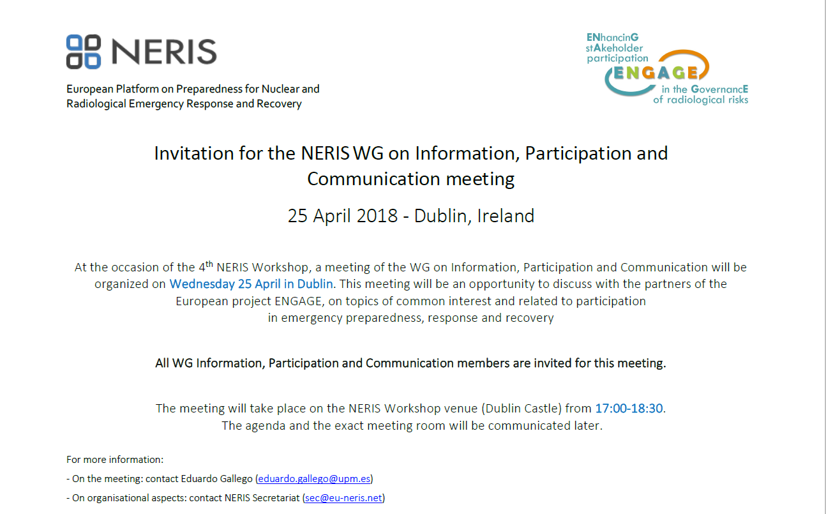

# logoAnnex 2 Agenda of the workshop

European Platform on Preparedness for Nuclear and   
Radiological Emergency Response and Recovery

**NERIS WG Information, Participation and Communication**

Wednesday 25th April 2018

17.00 – 18.30

*Dublin Castle - Dame Street - Dublin 2, Ireland*

1. Introduction. Review of past activities of NERIS WG on Information, Participation and Communication *-Eduardo Gallego (10’)*
2. Short summary of activities of TERRITORIES and CONFIDENCE on participation of stakeholders and communication of uncertainties *–* *Marie Simon-Cornu + TBD (10’)*
3. Discussion on the following topics (20 min each, 3 groups, rotation of topics):
   1. Frameworks and rationales for stakeholder engagement, *ENGAGE project, moderated by Bieke Abelshausen*

The following questions will be used as a starting point for the discussions:

- Who is (should be) a stakeholder in your experience?

-Why should stakeholders be involved in emergency preparedness and response? What are the strengths- weaknesses-opportunities and threats?

* 1. Knowledge base for stakeholder engagement, *ENGAGE project, moderated by Tatiana Duranova*

The following questions will be used as a starting point for the discussions:

-Which form of knowledge base for stakeholder engagement will make it meaningful for you?

-Which information is most useful for you?

- What is the best way of sharing the generated knowledge?

* 1. Participation, information and transparency in practice, notably in light of – but also beyond - the new BSS and new Safety Directive *- ENGAGE project and BSS, moderated by Tanja Perko*

The following questions will be used as a starting point for the discussions:

-How should Member States interpret the public information requirements from BSS and amended Nuclear Safety Directive

-Can you point out a specific good practice at the national level regarding information provision and transparency in case of an emergency?

1. Redesigning of the NERIS WG-IPC objectives and activities (future of the NERIS knowledge data base)*-* *Eduardo Gallego (15’)*